Design Updates
URL:
http://us15.campaign-archive2.com/?u=12a794b2402eb103cba5c25f4&id=2e2bbb4e97
- Post my Flight Button - Button needs to be moved further left (see red line)
Currently:
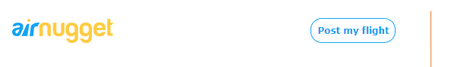
- Change the background image (you find the image in the folder)
Currently:

Update:
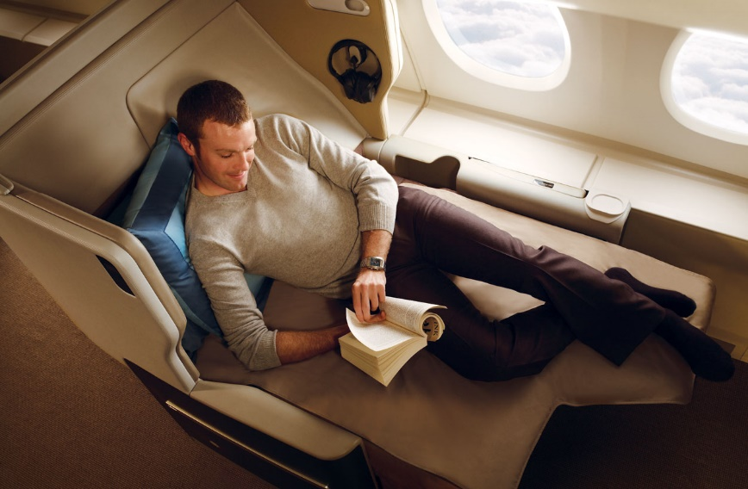

- Please use correct background image not grey background
Currently:
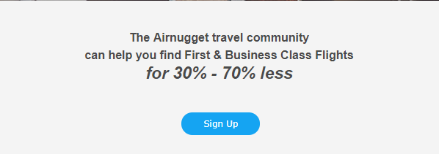
Update: (background image has famous buildings)
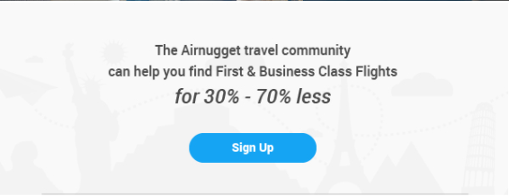
- Please move Sign Up button further up (see red arrow)
Currently:

Update:
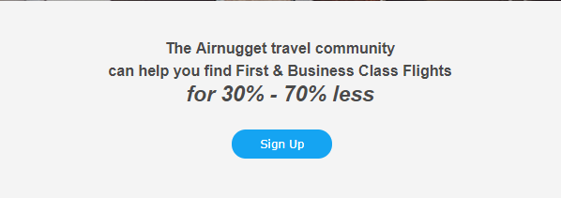
https://www.youtube.com/watch?v=6N30ysTK2Nw
- Button Link URL – Please update as below

https://plus.google.com/116469662694192725459/about
- Logo Link – Add link to Logo

https://airnugget.com/

